CSA1505 - CLOUD COMPUTING AND BIG DATA ANALYTICS
Experiment-4

- Create a simple cloud software application for Library book reservation system for SIMATS library using any Cloud Service Provider to demonstrate SaaS include the necessary fields such as Title of the book, author, publications, Year, edition, no of copies, Rack no, status (taken/returned) etc.

AIM:
To develop a simple Library Book Reservation System for the SIMATS Library using Zoho Creator (Cloud Service Provider) to demonstrate the Software as a Service (SaaS) model. The application allows users to manage book reservations, availability, and return status through a cloud-based platform.
PROCEDURE:
Log in to Zoho Creator.
Create a new application named SIMATS Library Book Reservation System.
Design a form with the following fields:
- Student Name
- Student ID
- Department
- Mobile Number
- Title of the Book
- Author
- Publication
- Year of Publication
- Edition
- Number of Copies
- Rack Number
- Reservation Date
- Return Date
- Status (Available / Taken / Returned)
Configure the required fields using text boxes, number fields, date fields, and drop-down lists.
Create workflows to:
- Automatically set the Reservation Date to the current date and time.
- Automatically set the Status to Taken when a book is reserved.
Save and publish the application.
Enter sample book and student details, then submit the reservation.
Verify that the reservation details are stored correctly and the workflows execute successfully.

INPUT:
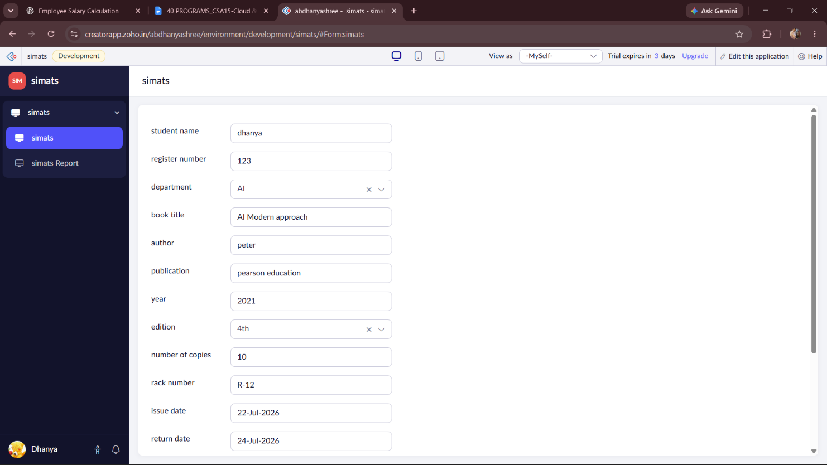
OUTPUT:
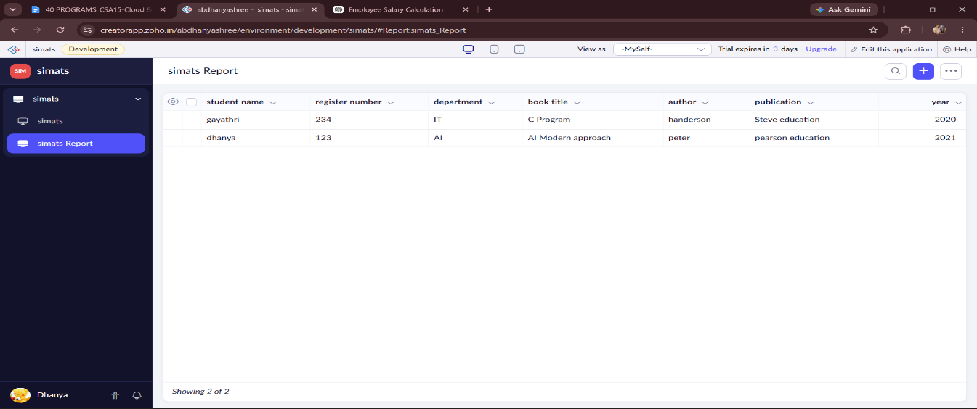

DESIGN:
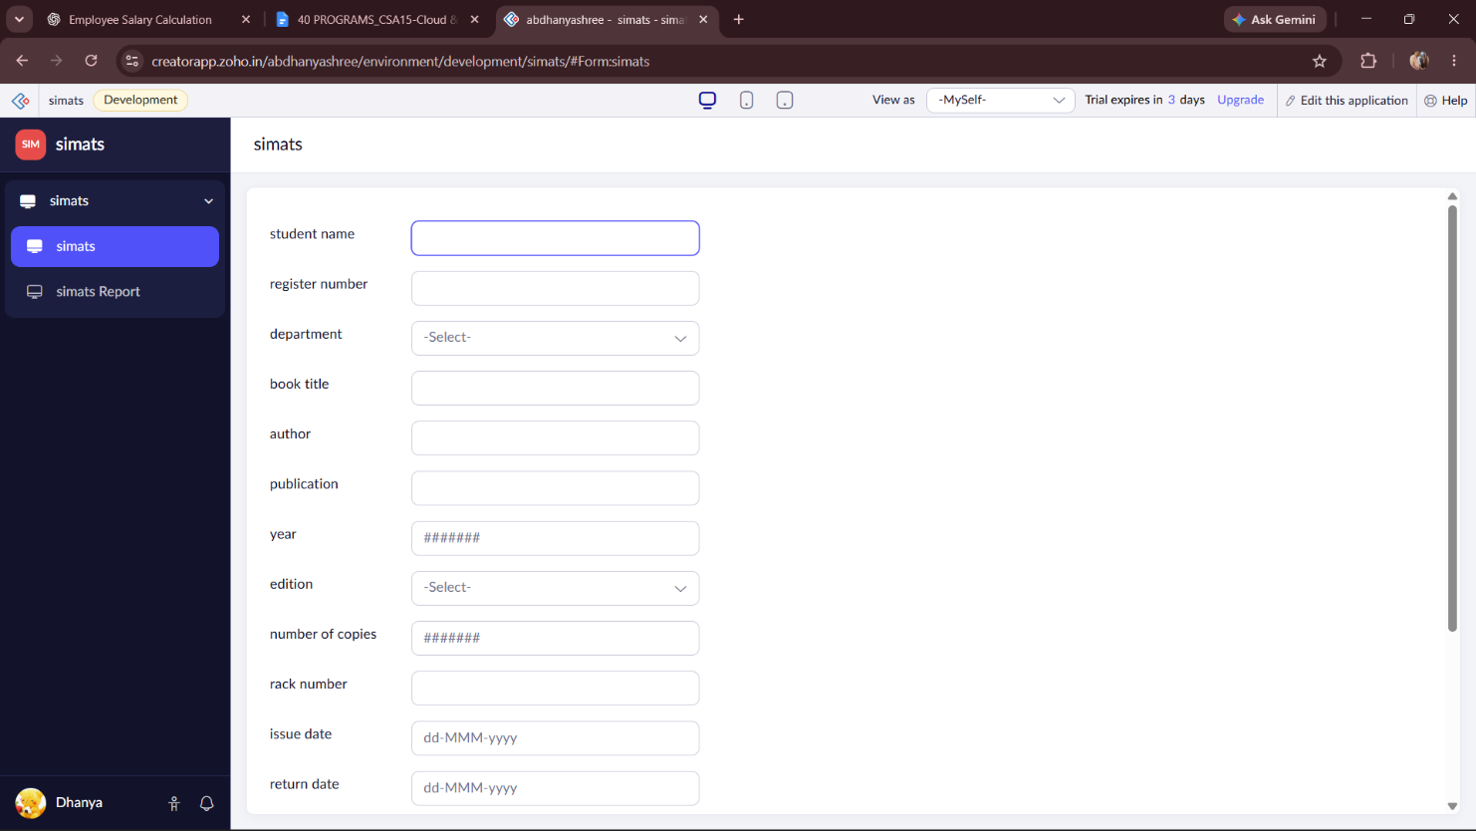

WORKFLOW:
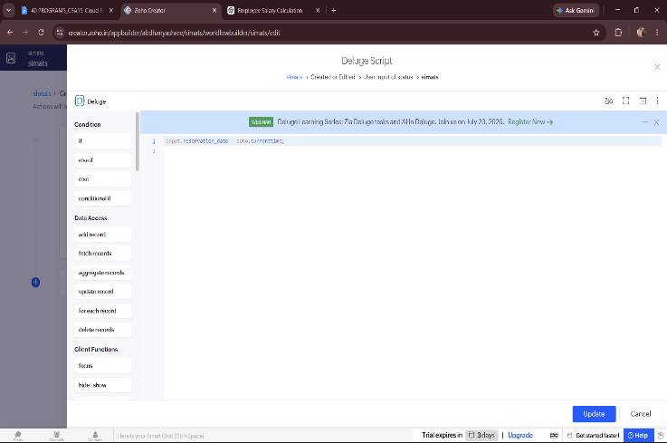
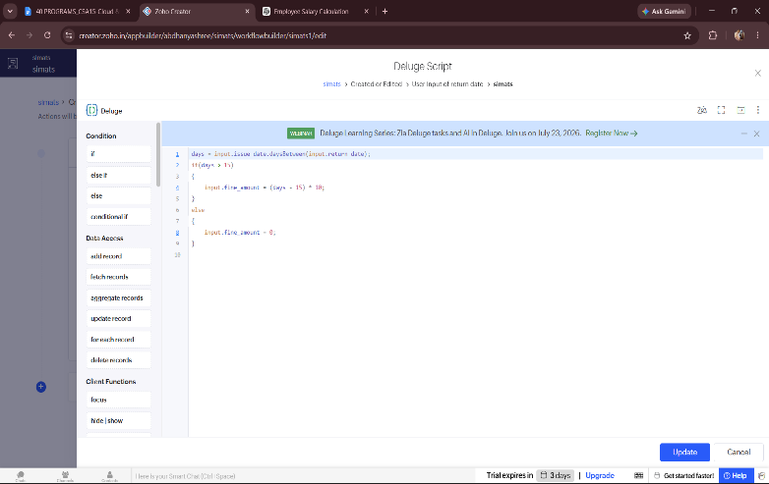

RESULT:
A cloud-based SIMATS Library Book Reservation System was successfully developed using Zoho Creator. The application enables users to reserve library books, maintain book details, track reservation and return dates, and manage the status of books (Available, Taken, or Returned). The automated workflows update the reservation date and book status, demonstrating the Software as a Service (SaaS) model in cloud computing.

